Burchard Galleries St Petersburg, FLEstate Antiques Fine Art Jewelry Auction12 PM Saturday December 10th, 2022

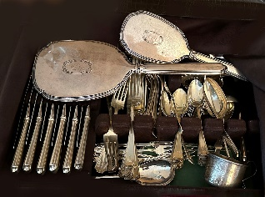

Many Sets of Sterling Silver. We Love Silver!

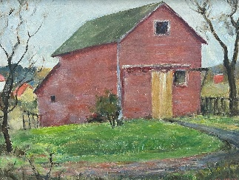

1190 Alma Held Oil

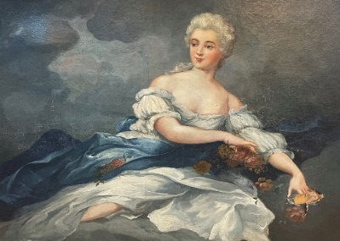

1019 Oil After Nattier

Huge Multi-Estate Astute Collectors Liquidation!

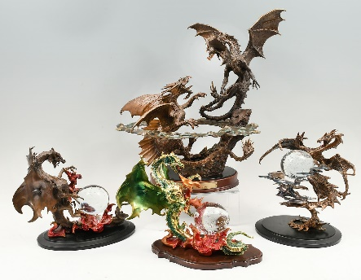

Dueling Dragons Franklin Mint by Michael Whelan

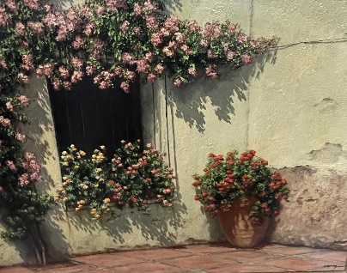

Many Oils by Maximo Cortina

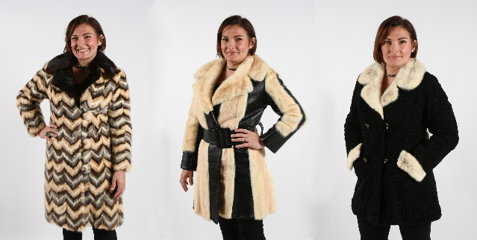

Stylish Furs, More inc Silver Fox

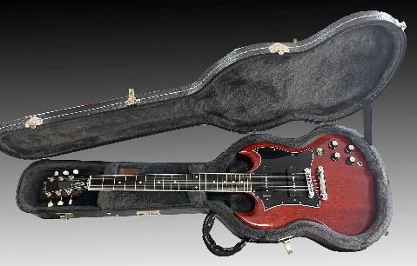

Many Guitars Including Gibson, Epiphone, Stella, Yamaha

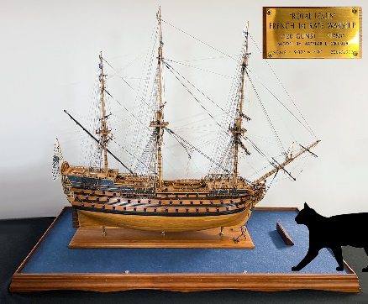

1010 Royal Louis Model Warship Model by Arthur Ortner

[mail@BurchardGalleries.com](mailto:mail@BurchardGalleries.com) 727-821-1167

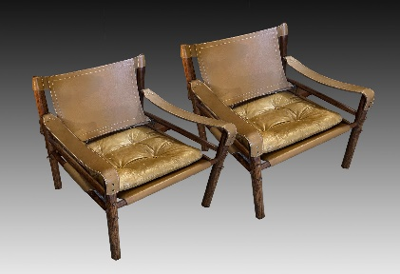

Pr Sirocco Safari Chairs by Arne Norell

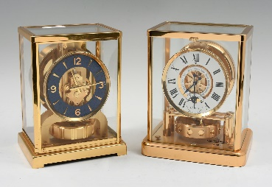

Rare Lapis Dial Atmos Clocks

Last Auction of 2022! Consignments Welcome

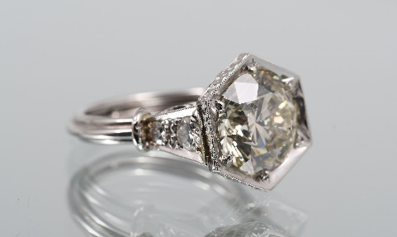

1050 5.03 CT Diamond Solitaire Mounting by Dino

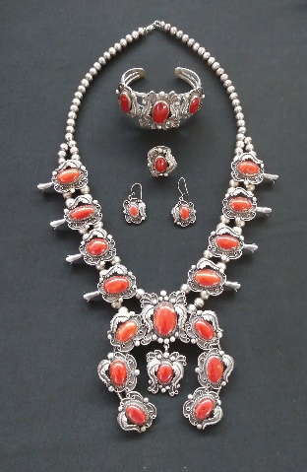

1007 Red Coral Sterling Squash Blossom

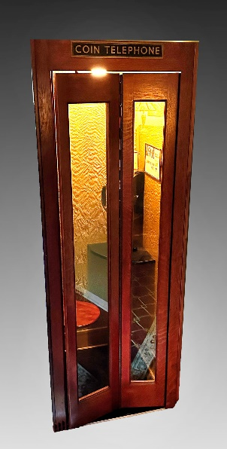

Superman's Phone Booth

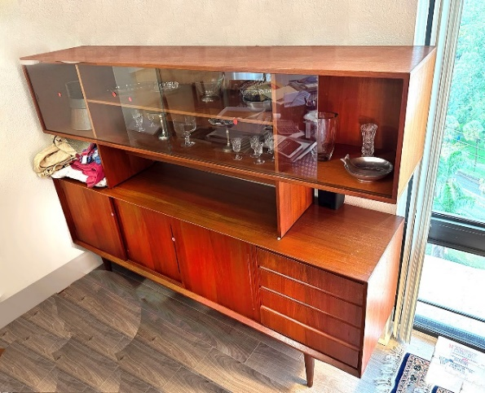

Mid-Century Modern Furnishings

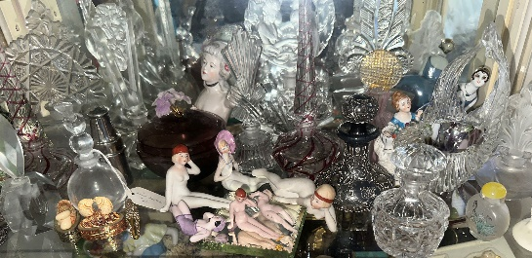

Perfumes & Naughty Nellies

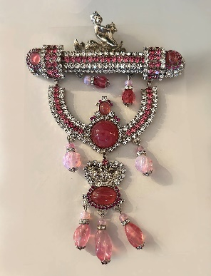

Chris Crouch Jewelry

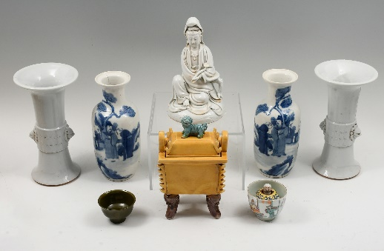

19th C Chinese Porcelains inc a Surprise Cup

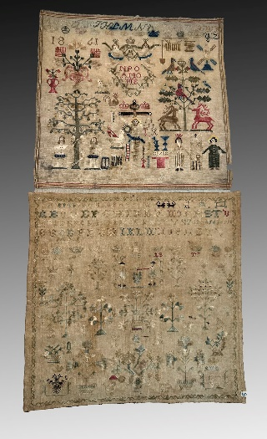

Extensive Collection 18th-19th C Samplers

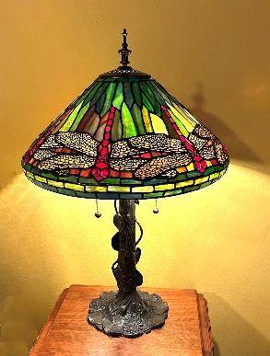

Many Vintage Lamps

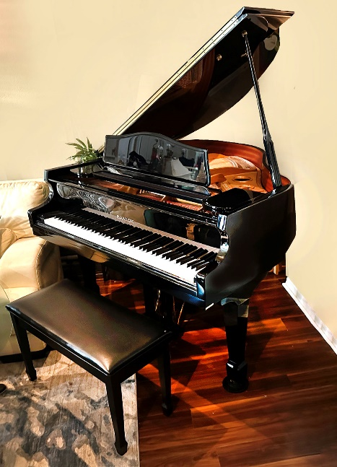

1205 Samick Black Lacquer Disc Piano

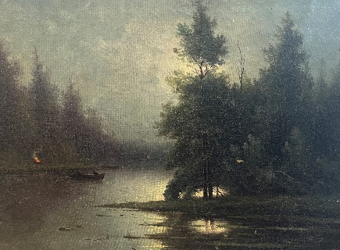

1185 Knute Heldner Oil